**Analyzing Climate – WORKSHEET**

Use your deductive reasoning and your answers to Questions 1-3 to explain how increased carbon dioxide levels have affected Earth and society through time using a claim-evidence-reasoning format.

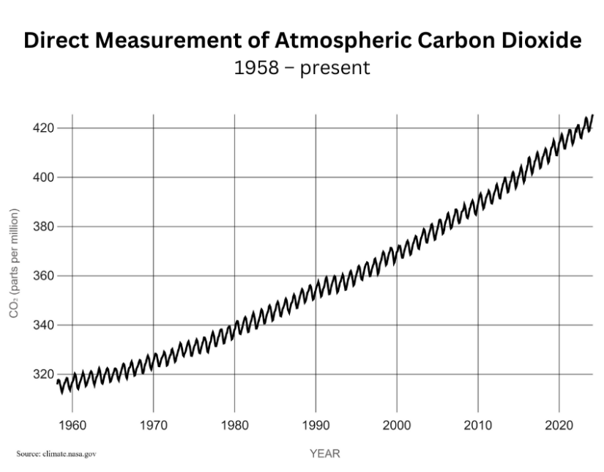This graph shows the direct measurement of carbon dioxide in the atmosphere, measured at the Mauna Loa Observatory, located on the Big Island of Hawai’i since 1958.

1. What trend do you see in this graph?

This graph shows the global surface temperature changes (red line) in watts per square meter since 1880. The lower line shows the Sun's radiation, or energy, received by the Earth in watts (units of energy) per square meter since 1880. The lighter/thinner lines show the yearly levels of variation. The heavier/thicker lines show the 11-year average trends.

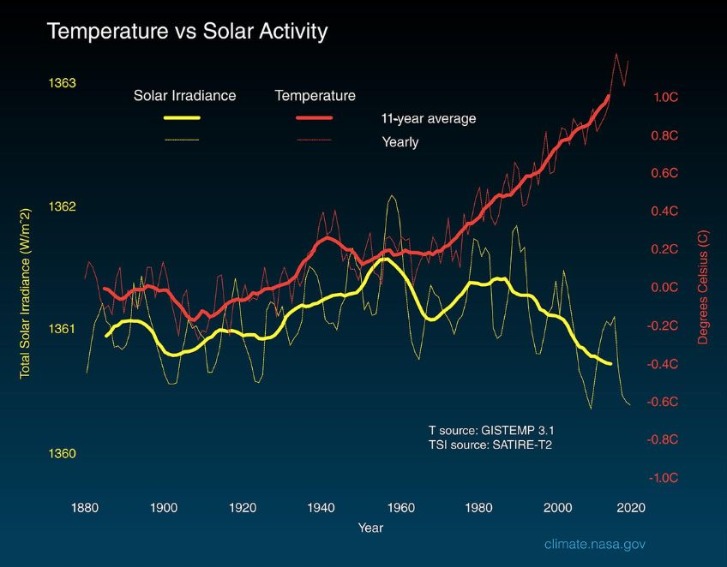

2. What trends do you see in this graph?

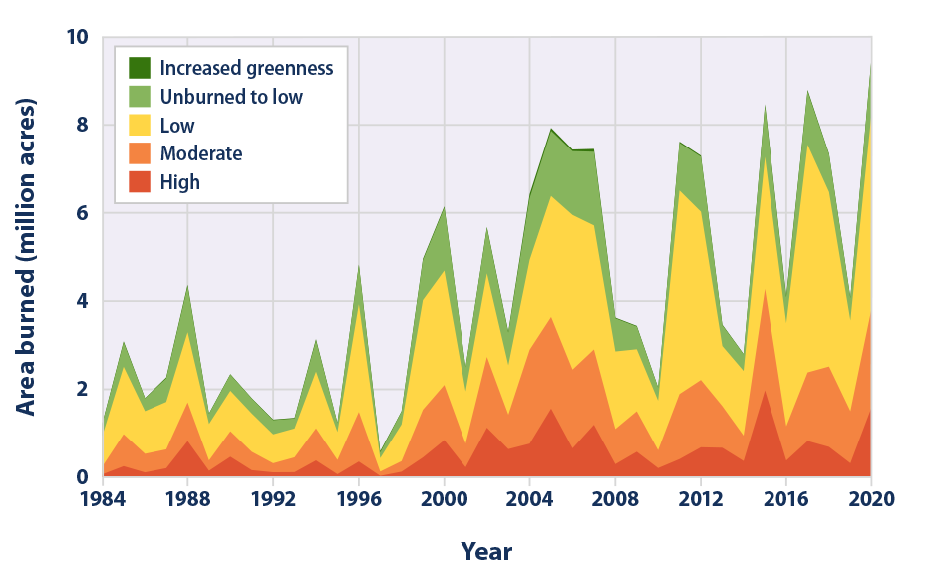Forests, shrublands, and grasslands cover more than half of the United States and are important resources. Wildfires occur naturally and play an important part in maintaining the health of these ecosystems. However, multiple scientific studies have found climate change has increased wildfire season length, frequency, and burned areas. Why? Climate change has resulted in longer, drier summers with drier soils and vegetation that burn more easily. This graph shows the damage wildfires have caused to the landscape in acres burned as a measure of wildlife severity since 1984.

3. What trends do you see in this graph?

4. How is the climate on Earth impacted by increasing carbon dioxide levels, and how do these impacts affect society? Start by stating your claim that answers the question. Then, list and describe the scientific evidence presented here. Explain why and how the evidence supports your claim. Last, make an evidence-based prediction for the future of Earth’s systems and society.